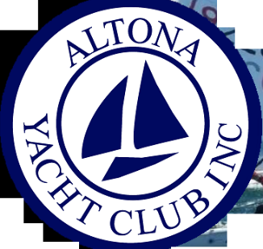

Altona Yacht Club Inc.
Training Centre

OPERATING PROCEDURES

INTRODUCTION
Welcome to the Altona Yacht Club Training Centre accredited by Yachting Australia. Based at 10 Beach Street, Seaholme VIC 3018, we offer club members and other members of the public nationally recognised training and qualifications.

We offer the following training course:
Basics Skills 1 / Basic Skills 2

MISSION STATEMENT
Our mission is to deliver quality training in a safe and enjoyable manner.

DUTY OF CARE
Club and race officials will owe a duty of care to participants in sailing races and activities where there is a reasonably foreseeable risk of harm or injury to participants as a result of their actions. In exercising this duty of care, the law requires officials to take reasonable steps to reduce the likelihood of injury to participants as a result of those risk which are foreseeable.

CHILD PROTECTION POLICY
All children under 18 attend the club only with their parents’ permission and knowledge.
No child may be left unattended at the club either while parents are sailing or if parents decide to leave the club environs.
The club will have a documented safety policy for all areas, on and off shore.
Children and other vulnerable people will be given appropriate safety and protection whilst in the care of the Altona Yacht Club.
Altona Yacht Club and its members will follow a code of conduct for people working with children and other vulnerable persons (Appendix A).
The club provides procedures for raising concerns or complaints (Appendix B).

Code of Conduct for People Working with Children

Appendix A
Always be publicly open when working with children.
Avoid situations where you and an individual child are completely unobserved.
Where possible parents should take responsibility for their children in changing rooms.
If groups are to be supervised in changing rooms, always ensure that adults work in pairs.
Volunteers and professionals must respect the rights, dignity and worth of all and treat everyone with equality.
Volunteers and professionals must place the well-being and safety of the sailors above the development of performance.
Adults must ensure that the activities which they direct or advocate are appropriate to the age, maturity and ability of the performer.
Adults should always promote the positive aspects of their sport (e.g. fair play) and never condone rule violations.
Adults must consistently display high standards of personal behaviour and appearance.
Adults should never overtly criticise athletes or use sarcasm where it may cause the person to lose self-esteem or confidence.
Members should be aware that as a general rule it does not make sense to spend amounts of time alone with children away from others.

Appendix A
All suspicions and allegations of abuse will be taken seriously, responded to swiftly and appropriately. Staff/ volunteers are not trained to deal with situations of abuse or to decide if abuse has occurred. However, they should be aware of their responsibility to report concerns if they arise.
All staff (paid/ unpaid) working in the club have a responsibility to report concerns to the appropriate officer.

ACCIDENTS, INCIDENTS AND NEAR MISSES
All accidents, incidents and near misses are to be reported to the training principle at the earliest possible time in the form of an “Incident Notification Form”. This form will assist in the investigation and resolution of the incident.

EMERGENCY PROCEDURES

Emergency Contact information
Altona Yacht Club Ph: 03 9398 5859
The closet public telephone is located outside the canteen.
Police/ Ambulance Emergency Services Number Ph: 000
Water Police Ph: 000
Next of kin details of students are held by the Training Principle.
If there is an on water emergency, the rescue craft will assist and determine the type of action required. The rescue craft will radio the Altona Yacht Control Tower and advise if assistance is required.
Safety/ Rescue Boats must be on the water and patrolling when training boast are sailing.
First Aid equipment is located in the wet area outside the canteen. All First Aid treatment is to be conducted by a current qualified firs aid person and all treatment is to be recorded on the “Record of Treatment” form.
All Altona Yacht Club Instructors are qualified Fist Aid Personnel.
Location of the nearest Medical Facilities is the Williamstown Hospital, Railway Crescent, Williamstown, Victoria 3016.

________________________________________________________________________________

OPERATING PROCEDURES

Altona Yacht Club Site Layout
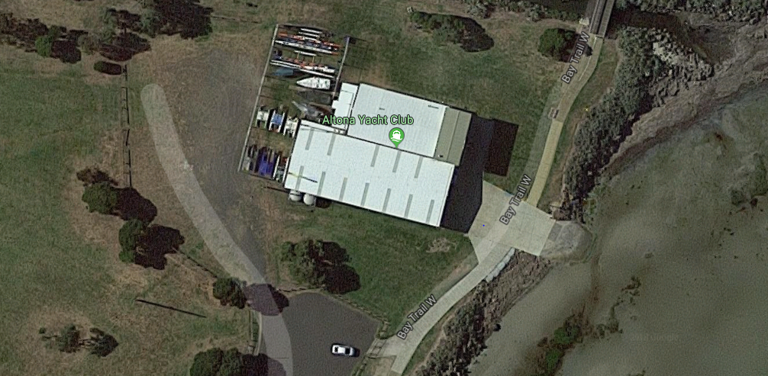

Training Area Map
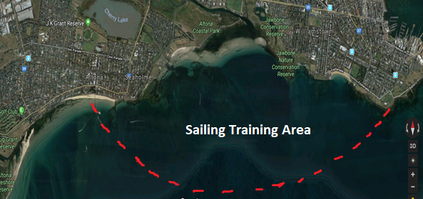

Training for the club to be held as close as practicable to the Altona Yacht club and/ or within the Sailing Training Area as shown above.

Booking Procedures and Enrolment
Information regarding the sailing course offered by the Altona Yacht Club is obtained directly from the club or by telephoning or emailing the Sailing principle via the internet at www.altonayachtclub.org.au
Before sailing training can begin, the student enrolment form must be completed, insuring a next of kin is listed, paying particular attention to clauses (c) through to (m), and signed. If the student is under the age of 18, signature if required by a parent or guardian.
Before going on the water a Safety briefing is conducted to ensure students are fully briefed on all safety aspects of Sailing.

Environmental Issues Affecting Training
If actual wind speed is in excess of 15knits no on water activity training will take place.
If there is a weather warning or thunder storm no water activity will take place.
The Altona Yacht Club has a sailing simulator to use for training, seven Pacers, two Lasers and three Sparrows for training on the water.
The Altona Yacht Club Training Centre will provide PFD1 buoyancy vests to all students. PFD1 buoyancy vests must be fitted and worn for all water activity training.
Protective footwear must be worn (no bare feet) at all times during the training session including on and off the water training.
If it strongly recommended that sunscreen be used especially when on the water.
When launching and retrieving craft from the water, a minimum of two persons must assist with this procedure.
Water craft are maintained regularly, however, if a student or instructor identifies any faults they are to report them to the Training Principle.

